Post-Flight Connectivity Summary Using Multimodal LLMs for Data Analysis

**Proposal**

Develop a system to analyze network connectivity graphs and CSV files by comparing them against a database of flight data representing expected flight data characteristics. The system will determine if the connectivity depicted aligns with typical patterns and provide insights or alerts about any deviations.

#### **Project Overview**

This keystone project was developed to provide a summary of in-flight connectivity for aircraft owners, flight crew, and pilots. This tool leverages an open-source multimodal large language model (LLM) to process and analyze flight data, offering an analysis of connectivity events during flights. The primary objective is to enhance the customer experience by providing real-time, data-driven insights into connectivity performance.

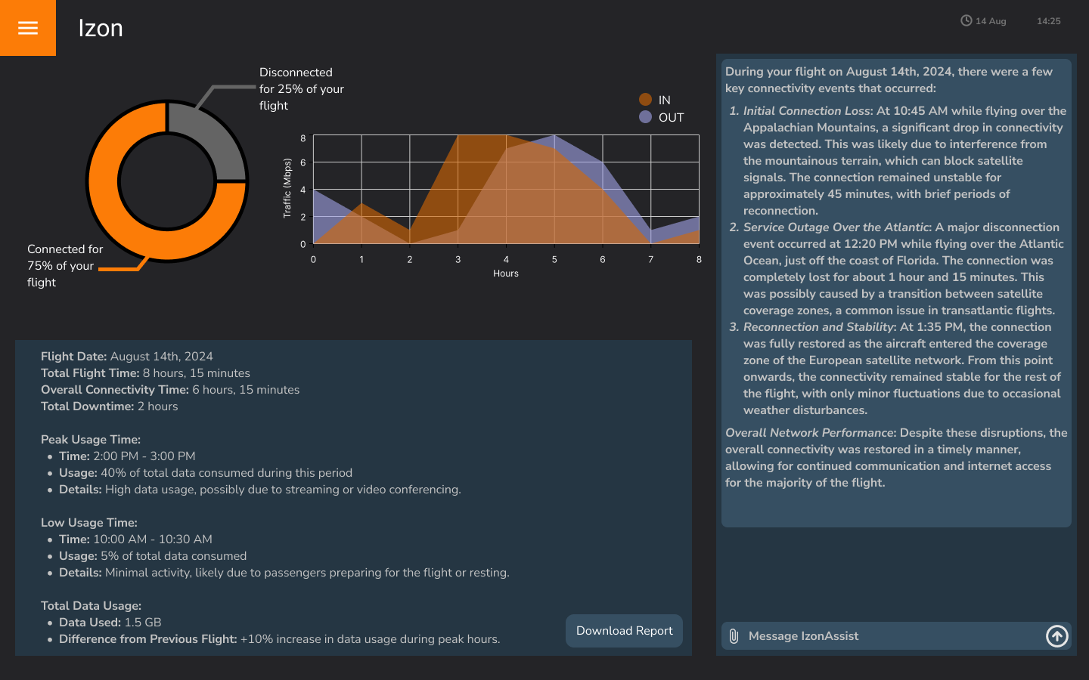

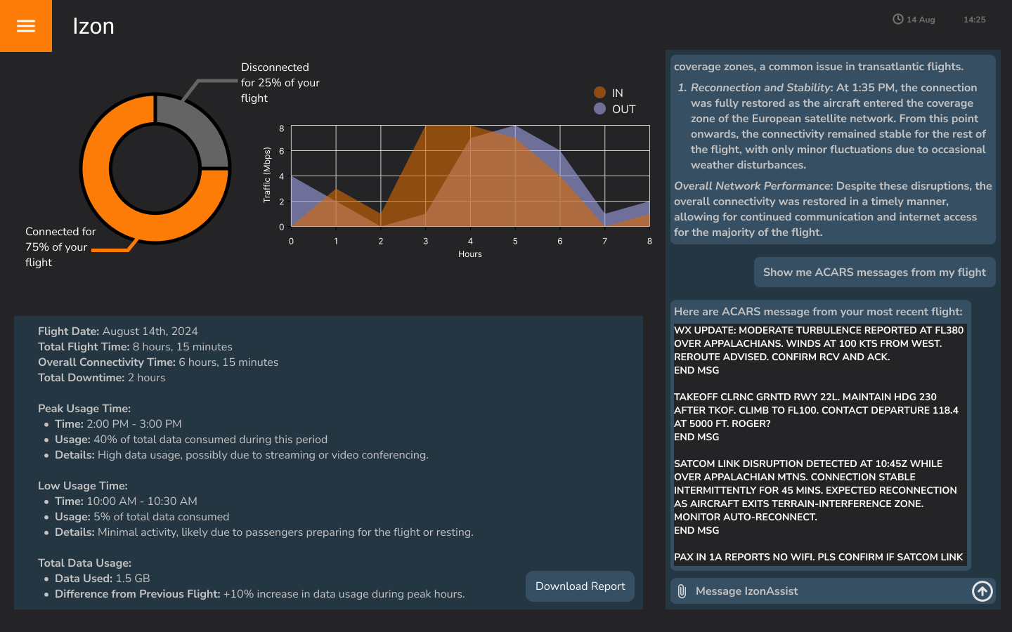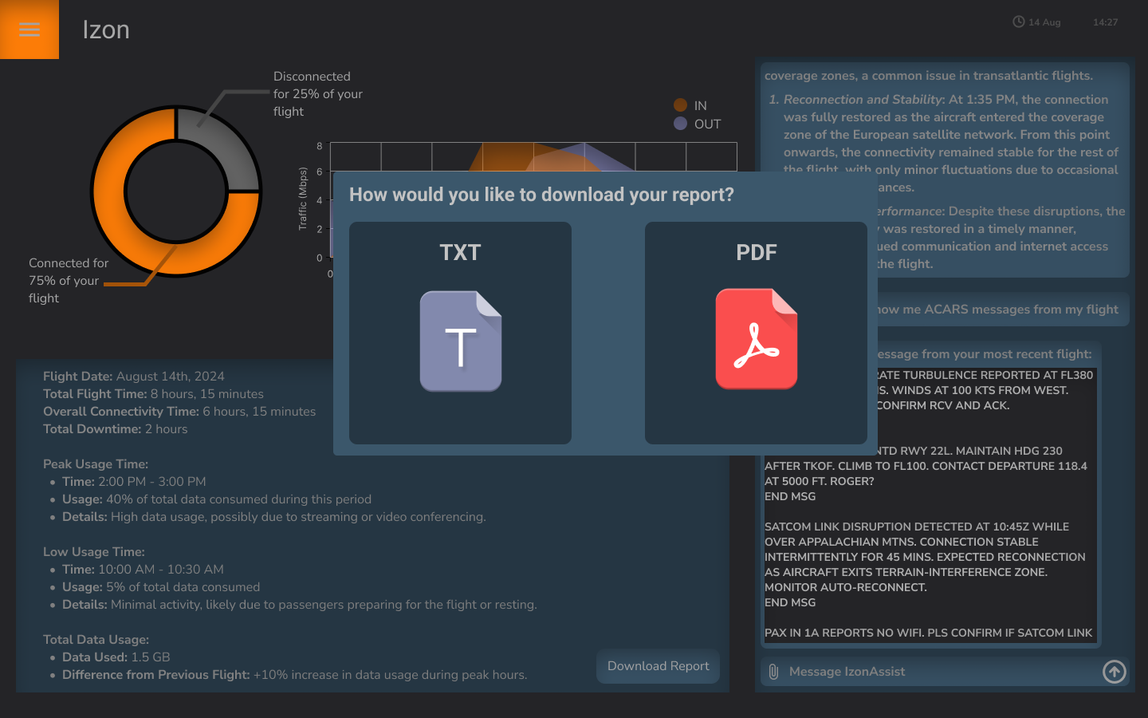

#### 

#### **MVP/Proof-of-Concept**

The minimum viable product (MVP) analyzes graph images and CSV files containing connectivity data. Key components of the MVP include:

* **File Upload Capability**: The tool allows users to upload connectivity graphics or CSV files containing flight data. Both file types are processed through the same interface.
* **AI Integration**: The MVP uses a locally hosted multimodal LLM to analyze the uploaded data and generate summaries of connectivity performance, identifying key events such as peak usage time, low usage time, and differences compared to previous flights.
* **Database Integration**: A MySQL database was set up to store uploaded data, ensuring that flight data could be accessed and analyzed consistently across sessions.

#### 

#### 

#### **Feature Development**

Building on the MVP, several features were added to enhance the tool’s functionality in the form of a Figma mockup:

* **Visualization**: The tool was extended to include visualizations, such as a pie chart showing connected vs. disconnected time, a graph showing incoming and outgoing traffic, and summary metrics like peak usage time, low usage time, and key differences in connectivity.
* **Data Analysis**: The volume and types of data that the tool can support could also be increased, such as flight path, aircraft messaging, and fuel information.
* **User Interface Design**: The Figma mockup was created to guide the development of a user-friendly interface. The design emphasizes simplicity and accessibility, allowing users to easily interpret the analysis and summaries provided.
* **Automated or Manual Reporting**: The tool can be further developed to automatically generate post-flight connectivity reports. These reports could summarize key connectivity events, providing information that can be used to optimize future flights. Two different flights could also be compared by selecting them from a list of past flights.

#### **Next Steps**

* **Further AI Enhancement**: Further development of AI models, including training and fine-tuning models for the specific use case of analyzing and summarizing connectivity data.
* **Ongoing Optimization**: Future work will focus on refining an AI model, improving data accuracy, and expanding the tool’s capabilities to include additional metrics and reporting features.
* **Customization and Scalability**: Continued development will also include customization for different user groups (e.g., flight crew, maintenance technicians, general admins) and ensuring the feature can scale efficiently.
* **Prevent False Information**: AI agents could potentially be used as part of the data flow to verify responses and ensure consistency.

**Potential Models**

|  |  |
| --- | --- |
| LLaVa | Large Language-and-Vision Assistant, or LLaVa, is an open-soruce multimodal large language model designed to understand and generate responses based on visual and text-based input. |
| Mistral | Open-source model that offers top-tier reasoning for complex tasks. Often combined with LLaVa to create a multimodal “Ensemble Model”. |
| Llama 3 | Open-source model trained on text data, understands language well. |
| BLOOM | BigScience Large Open-science Open-access Multilingual Language Model is a 176-billion-parameter transformer-based autoregressive large language model. It generates structured data in the form of triples and adapts quickly to new tasks with minimal training data. |

#### 

#### **Roadmap**

Estimated 3-6 months

* Sourcing benchmark/training data
* AI training/fine-tuning
* Testing
* Deployment

# Cost-Benefit Analysis

#### **Costs**

1. **Development Costs**

**AI Development**:

* + Fine-tuning and training an open-source AI model to provide accurate and consistent summaries of in-flight connectivity would minimize development costs.
  + **Hardware:** GPUs, CPUs, RAM, etc.
  + **Software Development**: Developing the user interface, integrating with existing systems, and ensuring compatibility across platforms would involve collaborative efforts from multiple teams.

1. **Opportunity Cost**
   * Diverting resources (engineers, budget) from other potential projects could impact the development of other tools or innovations within the company.
2. **Maintenance and Support**
   * There isn’t internal AI expertise within ARINCDirect currently, additional resources may be required for long-term support and development

#### **Benefits**

1. **Improved Customer Satisfaction**
   * **Enhanced Flight Experience**: Providing aircraft owners and flight crew with detailed connectivity reports would improve their overall flight experience, leading to higher satisfaction and potentially increased customer loyalty.
   * **Proactive Issue Resolution**: Early detection of connectivity issues would result in quicker resolution, minimizing disruptions and ensuring a smoother experience.
2. **Operational Efficiency**
   * **Data-Driven Decision Making**: Engineers and flight operations teams can use the data from the tool to optimize their own operations.
   * **Reduced Downtime**: By analyzing connectivity patterns, future outages can be predicted and mitigated, reducing downtime and saving costs associated with lost productivity.
3. **Cost Savings**
   * **In-House AI Development**: While the initial investment in developing the AI may be high, it would reduce dependency on third-party solutions, leading to long-term cost savings.
4. **Competitive Advantage**
   * **Innovation**: Developing and implementing this tool would position the company as an innovative leader in aviation connectivity solutions, enhancing reputation and attracting new customers.
   * **Customizability**: An in-house solution allows for greater flexibility and customization, ensuring the specific needs of clients

#### **Conclusion**

While the upfront costs for developing this system for post-flight connectivity reports are significant, the long-term benefits—especially in terms of customer satisfaction, operational efficiency, and cost savings—outweigh the initial investment. The technology used in developing this tool could very well be applied to other use cases, and position Collins as an innovative leader in the industry.